Habit Maker

People suffer from procrastination and various issues nowadays the very reason for this is lack of habit.

This App helps to create a habit with having streaks every day, you free to quit any time that doesn’t make you a quitter. It really aims to create a habit so that you much continues them without the app

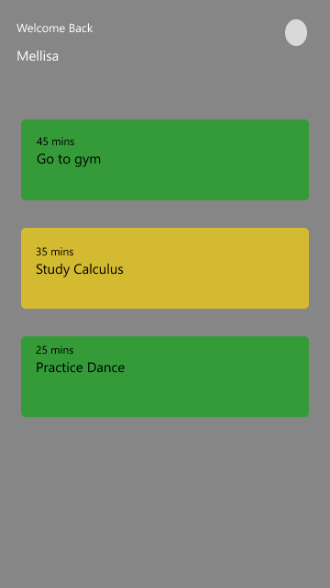

I was able to learn a lot about kotlin and jetpack-compose while making this.